# Assignment # 01

Prompt # 01:- Landscape

A beautiful view of landscapes filled with flowers

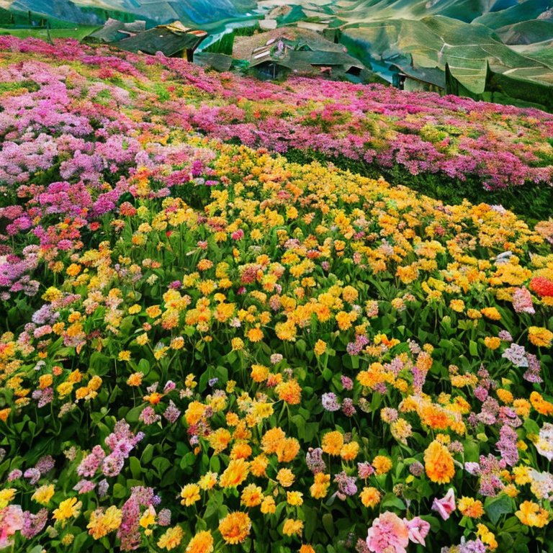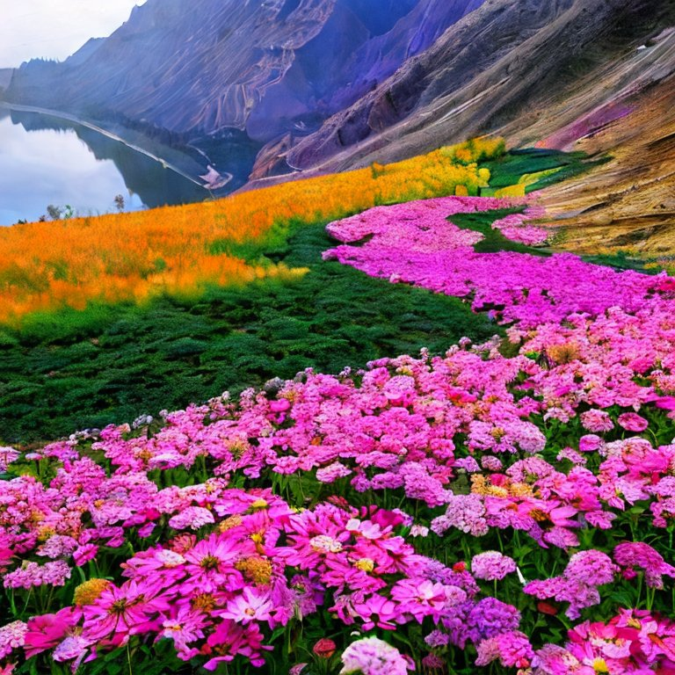

Prompt # 02:- Landscape

Landscape view of the pictures of lakes and scenery

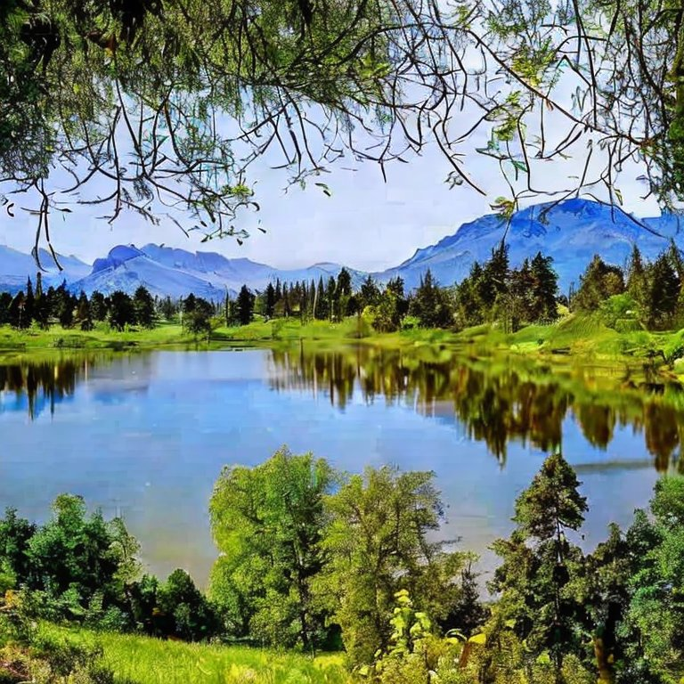 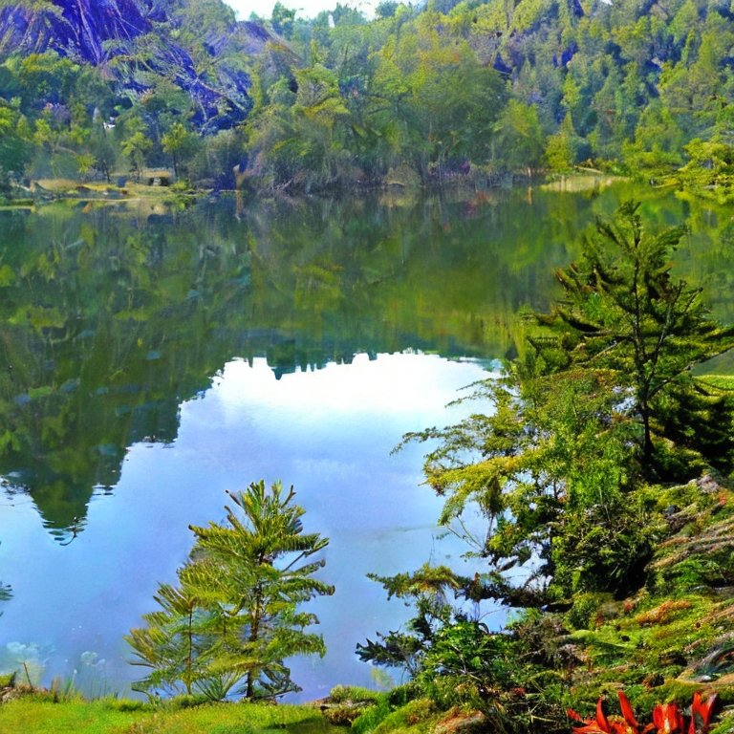

Prompt # 01 :- Animals

A picture of a proud lion sitting with a lionesses

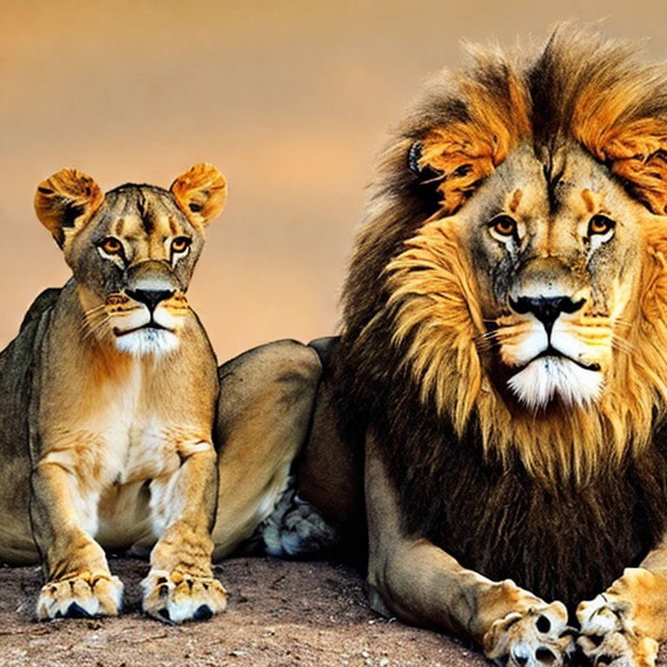 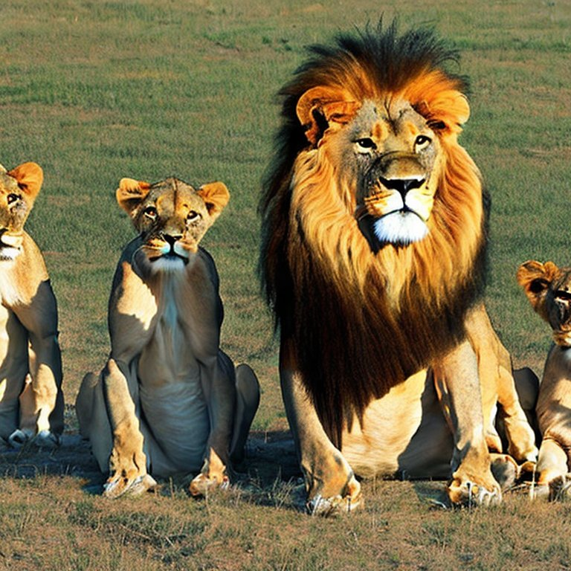

Prompt # 02 :- Animals

A beautiful white bull standing in a farm

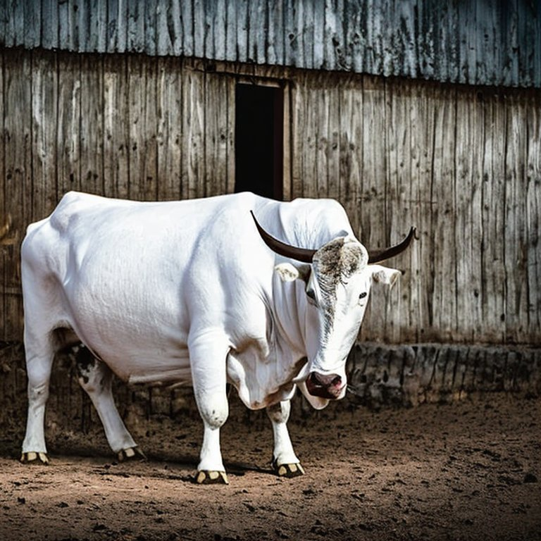 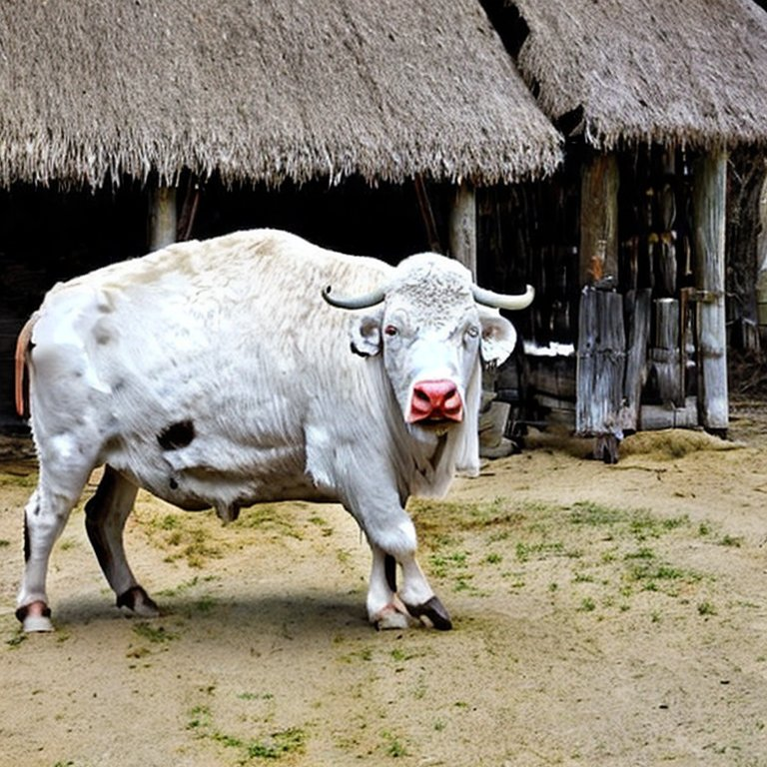

Prompt # 01 :- Abstract Art

Provide me a picture which is consisted of mixture of different colors

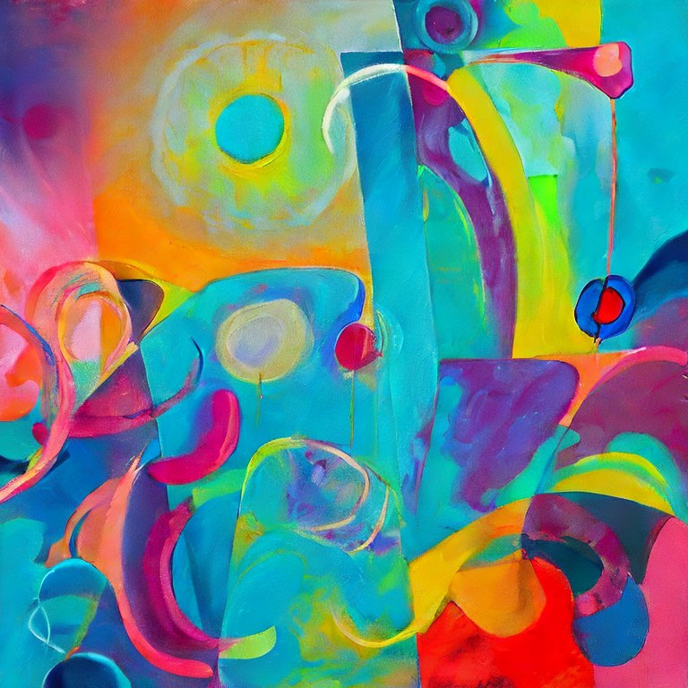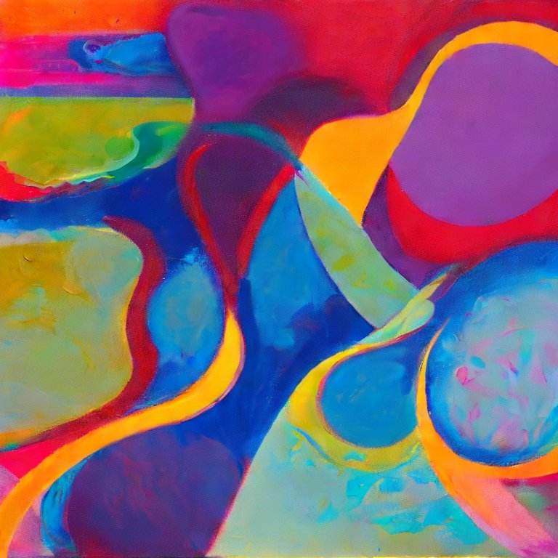

Prompt # 02 :- Abstract Art

Provide me a picture which is consisted of mixture of different colors

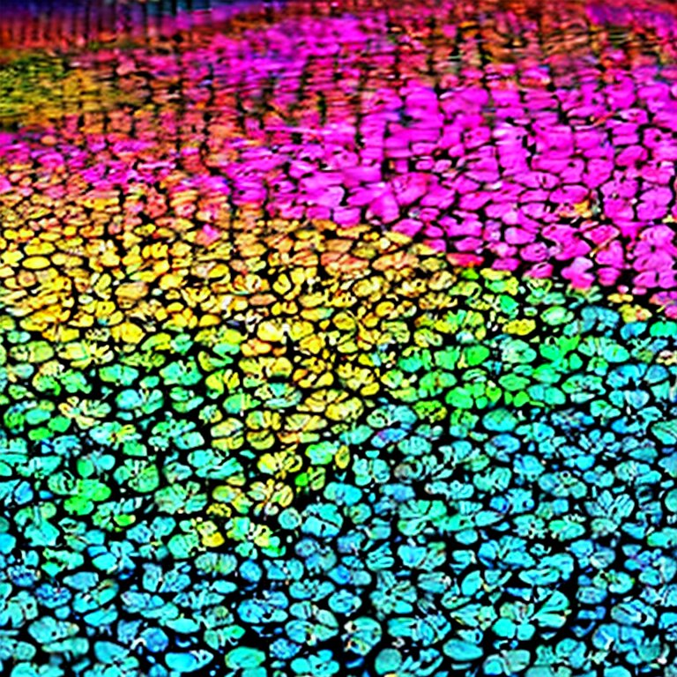 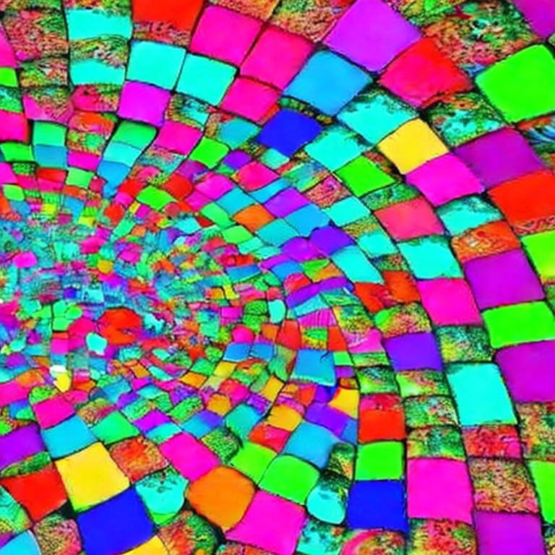

Prompt # 01 :- CityScapes

A beautiful dreamview of a cityscape at night time with gliters all around

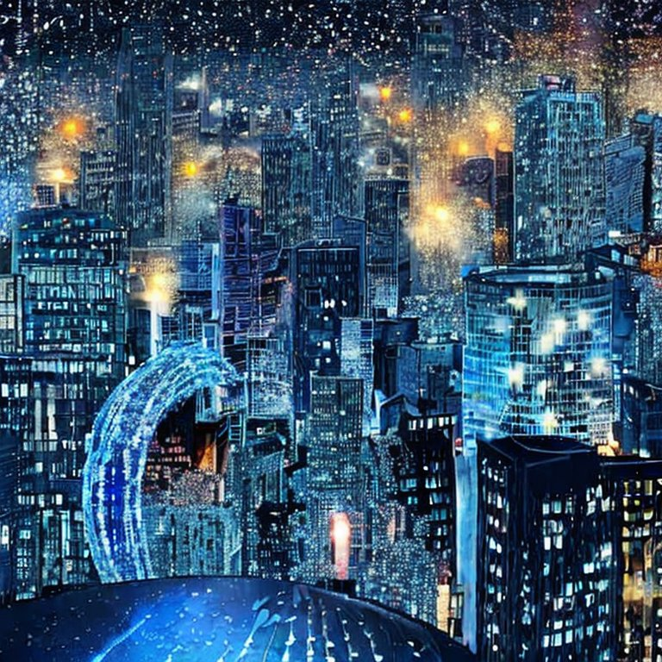 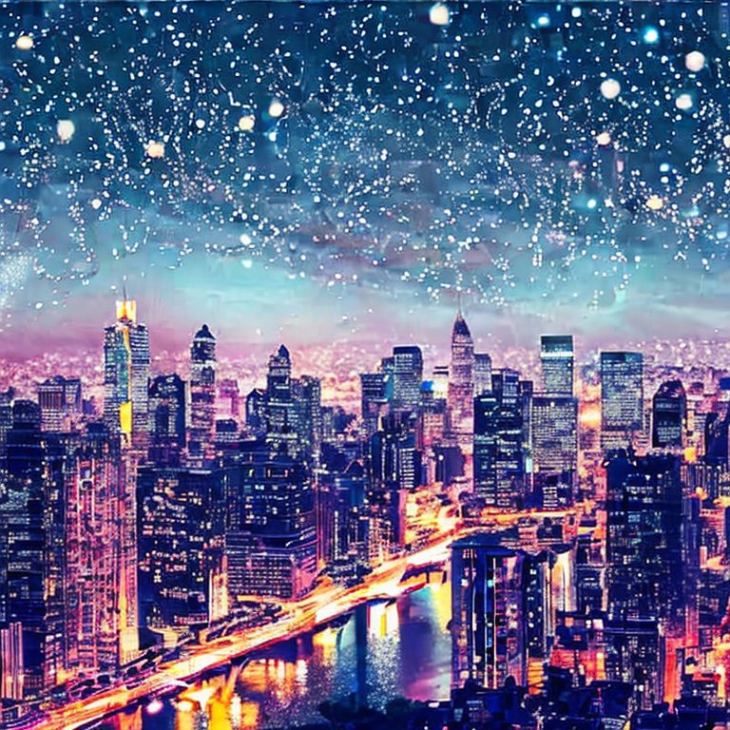

Prompt # 01 :- Sci-Fi and Fantasy

Transport yourself to a realm of magic and mythical creatures, and create an enchanting artwork that brings to life a captivating moment from a fantastical story.

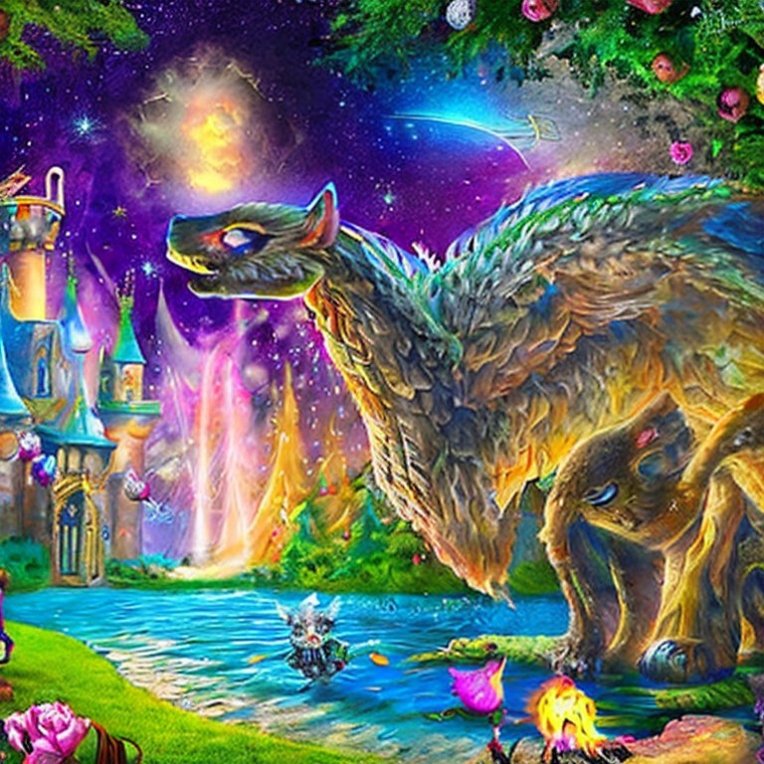 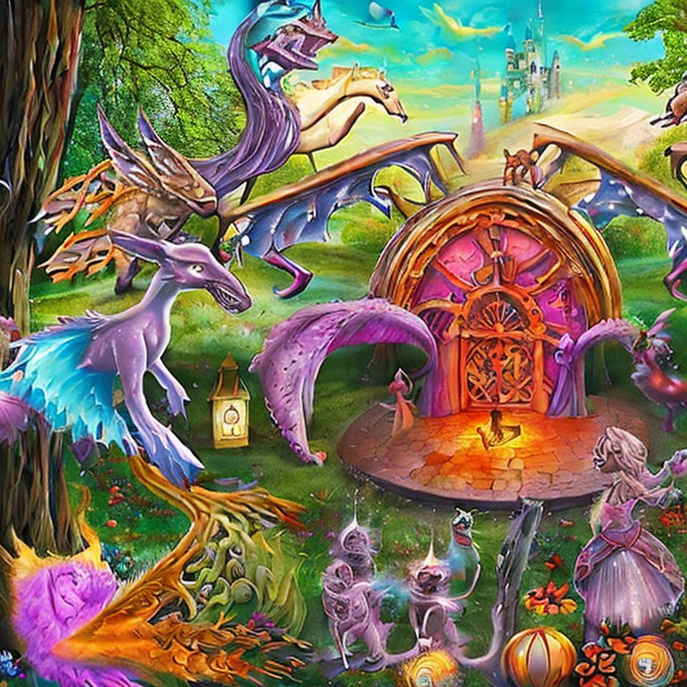

Prompt # 02 :- Sci-Fi and Fantasy

Picture a future where advanced technology and nature live together peacefully. Create an amazing scene that shows this special combination in a captivating way.

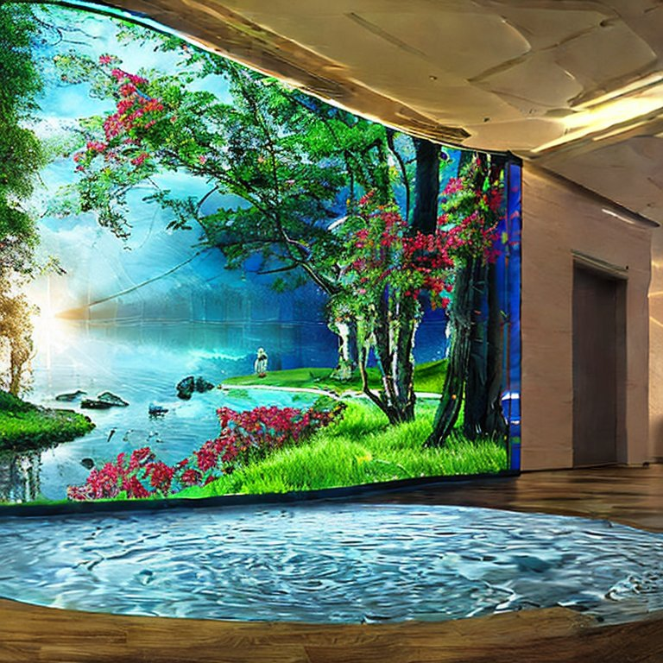 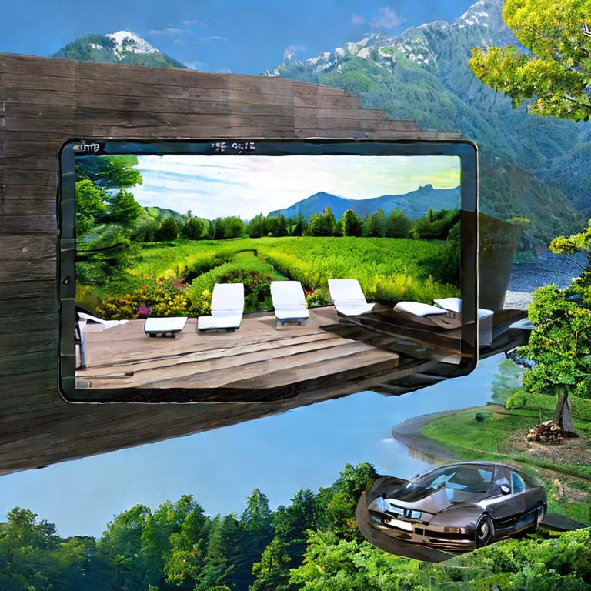

Prompt # 01 :- Portraits

Portrait of a very cute and naughty boy who is looking so fresh and energetic

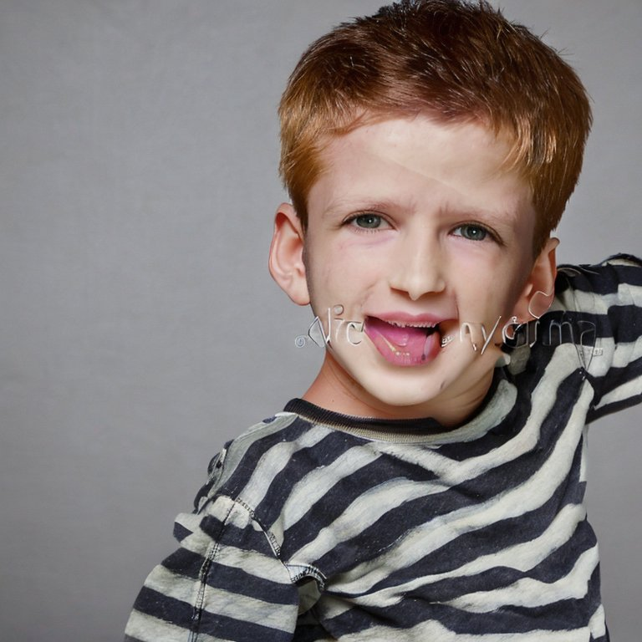

Prompt # 02 :- Portraits

A portrait of a painting created by a painter with great dedication and merging of different colors

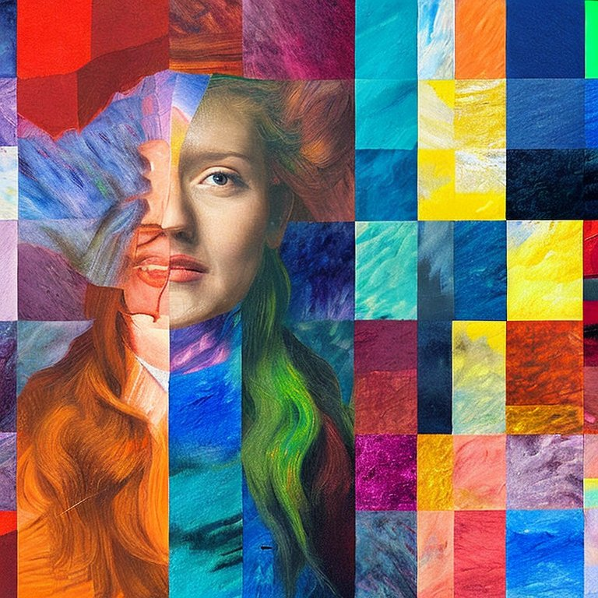 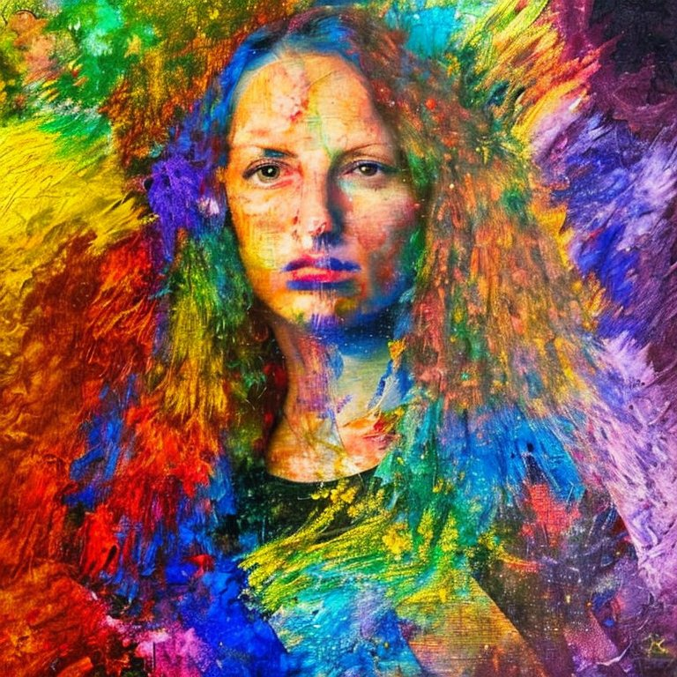

Prompt # 01 :- Still Life

Arrange objects in a still life that have different lights and shadows. Make it look interesting and mysterious by combining these contrasting elements. This will create a sense of curiosity and wonder.

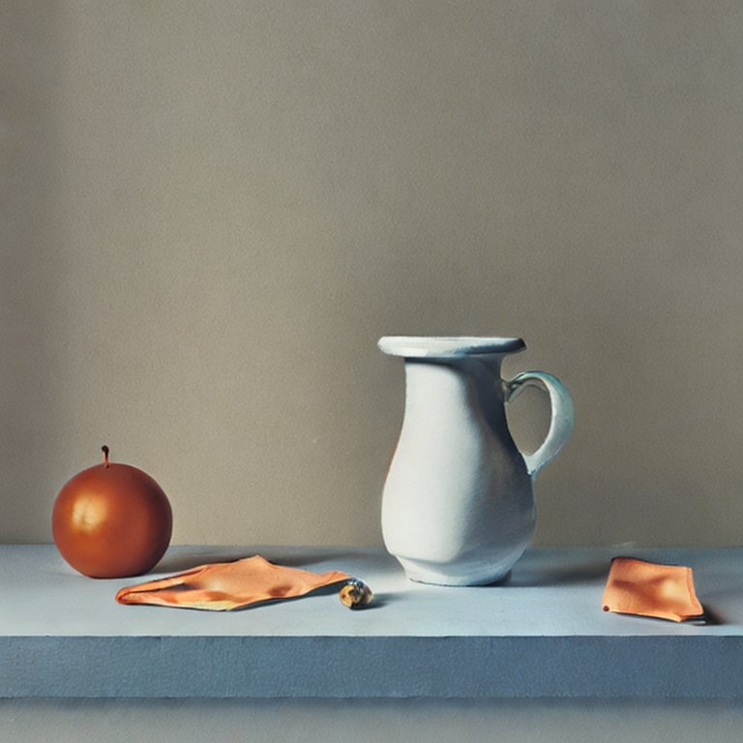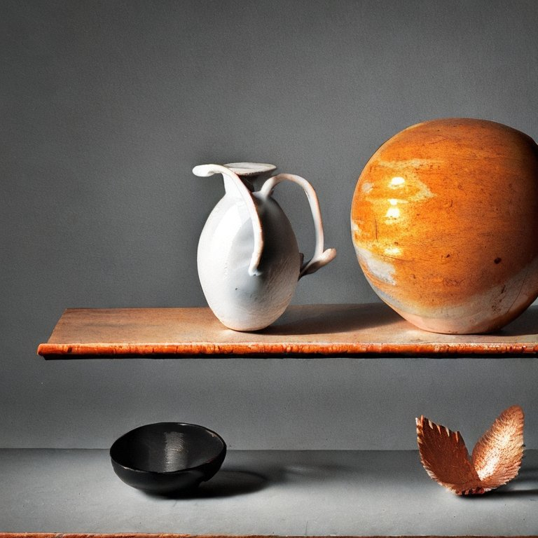

Prompt # 02 :- Still Life

Arrange a composition of everyday objects in a still life that captures the beauty of simplicity and invites viewers to appreciate the ordinary.

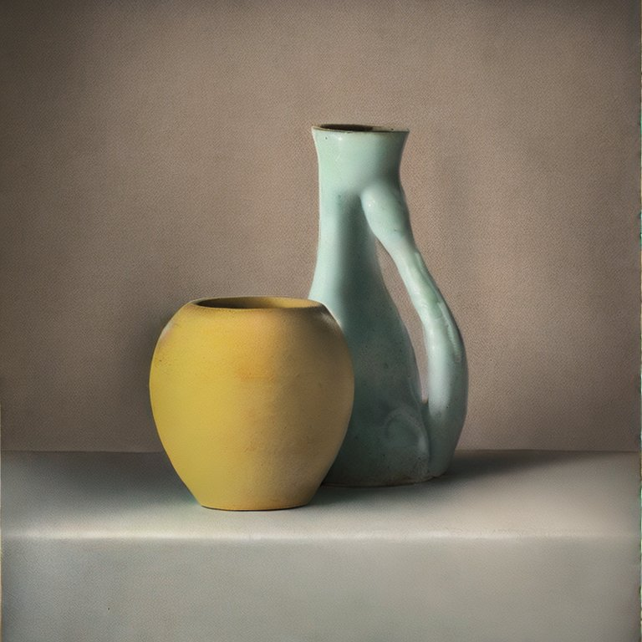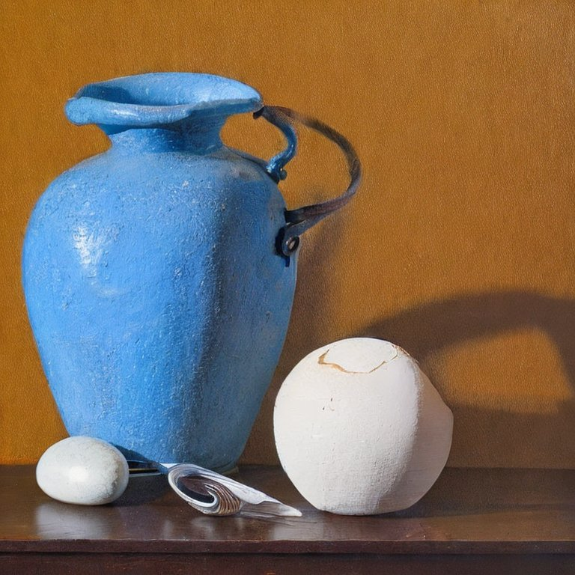

Prompt # 01 :- Nature & Botanicals

A beautiful view of the Nothern Areas of Pakistan which could be the source of happiness and pleasure for my eyes

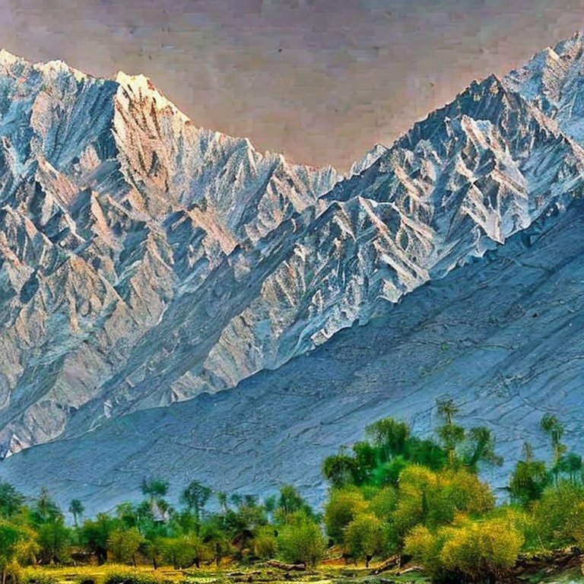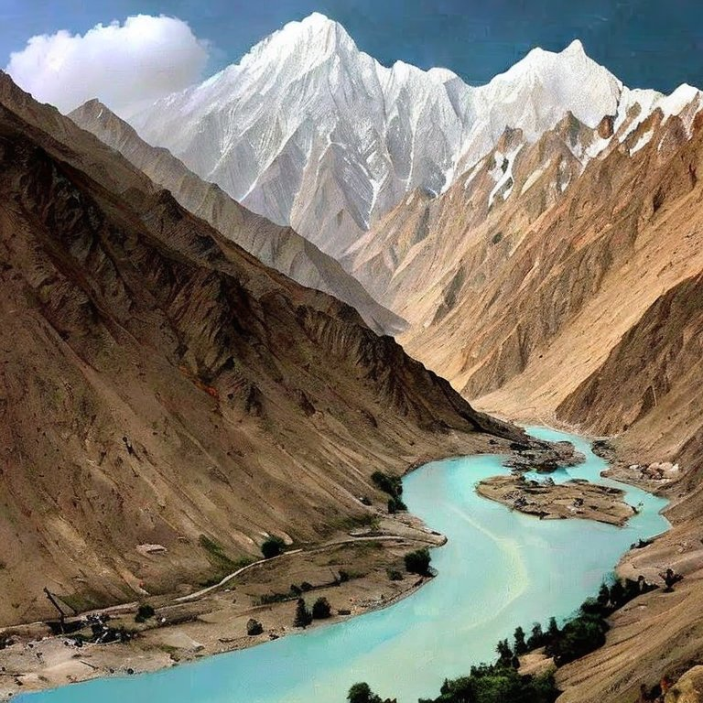

Prompt # 02 :- Nature & Botanicals

Capture the beauty of nature's vibrant colors and intricate details in a botanical illustration or painting. Let the flora and fauna inspire you to create a breathtaking artwork.

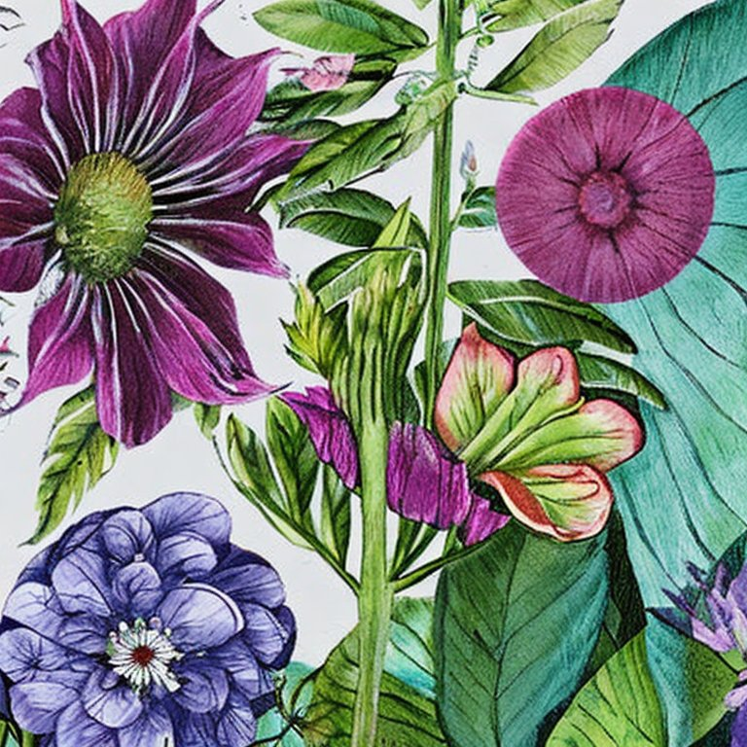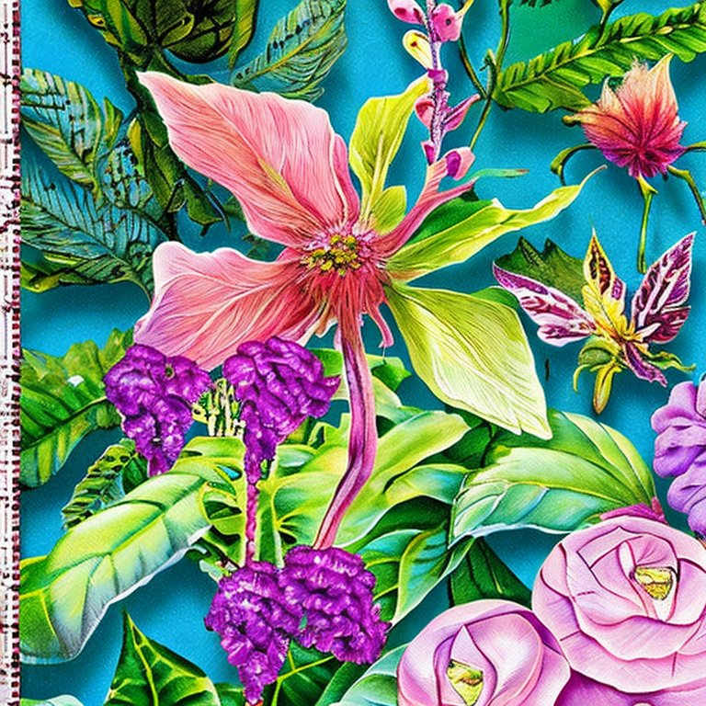

Prompt # 01 :- Architecture

Explore the fascinating world of architecture and create a captivating artwork that showcases the unique blend of design, form, and function found in architectural marvels. Let the structures inspire your imagination

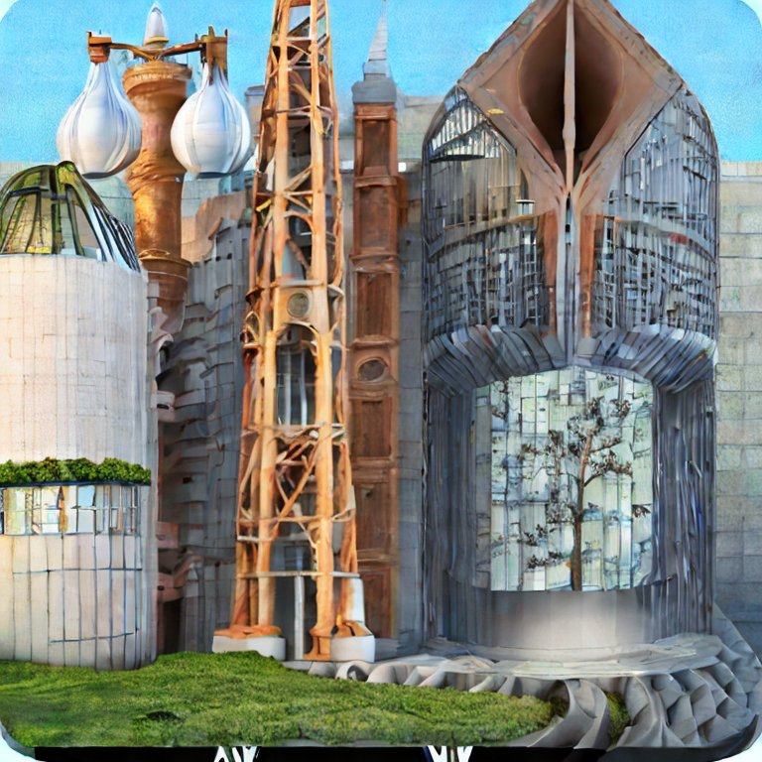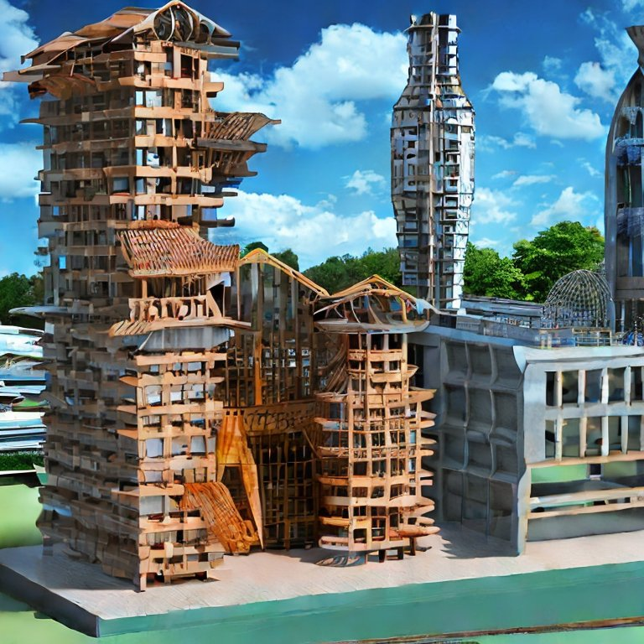

Prompt # 02 :- Architecture

Capture the essence of a specific architectural style, such as Gothic, Art Deco, or Modernist, in a striking artwork that celebrates the unique aesthetics and intricate details of that particular era.

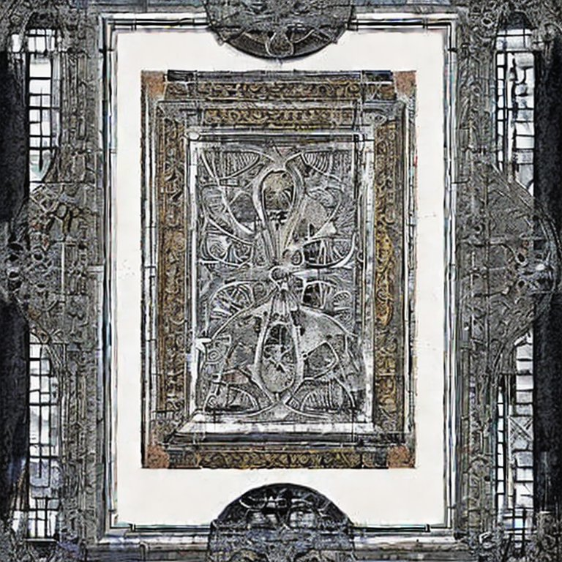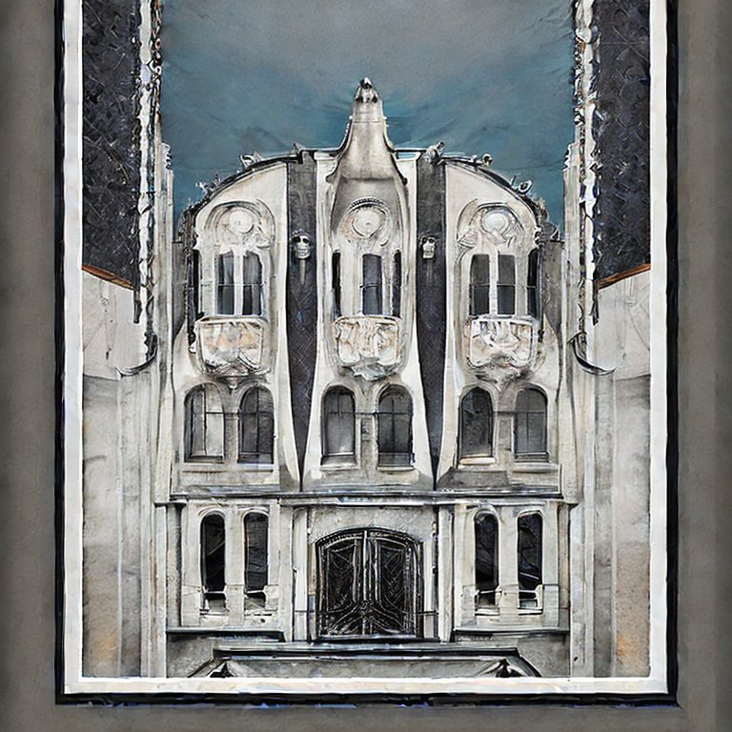

Prompt # 01 :- Surrealim

Create a surreal masterpiece that challenges reality and takes viewers on a captivating journey through the realm of imagination.

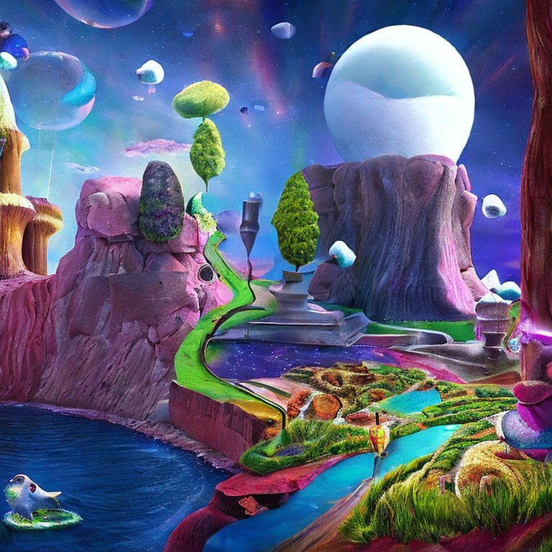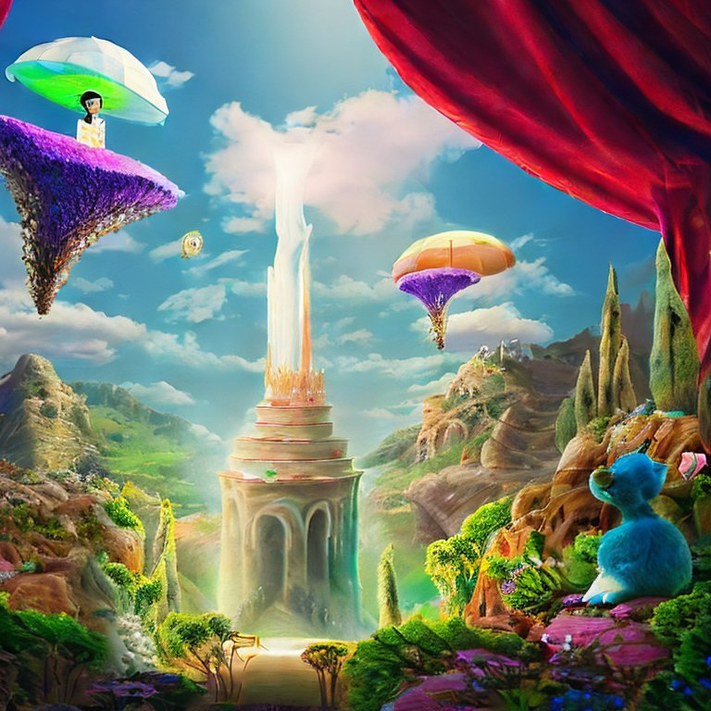

Prompt # 02 :- Surrealim

Transform the ordinary into the extraordinary by blending reality and fantasy in a surreal artwork that sparks intrigue and imagination.

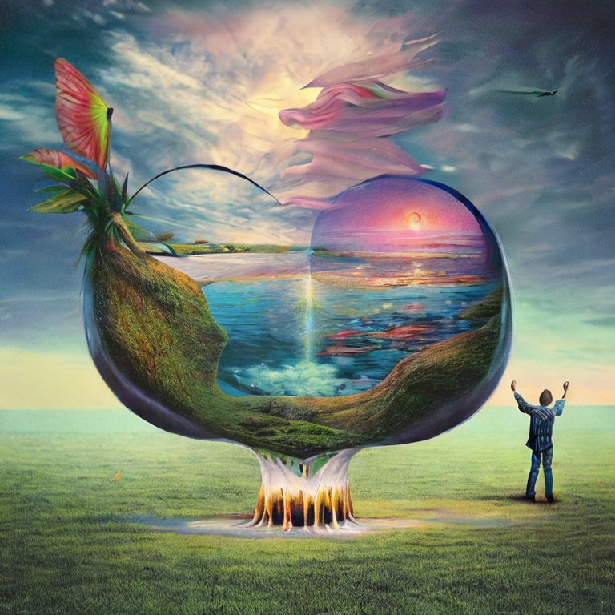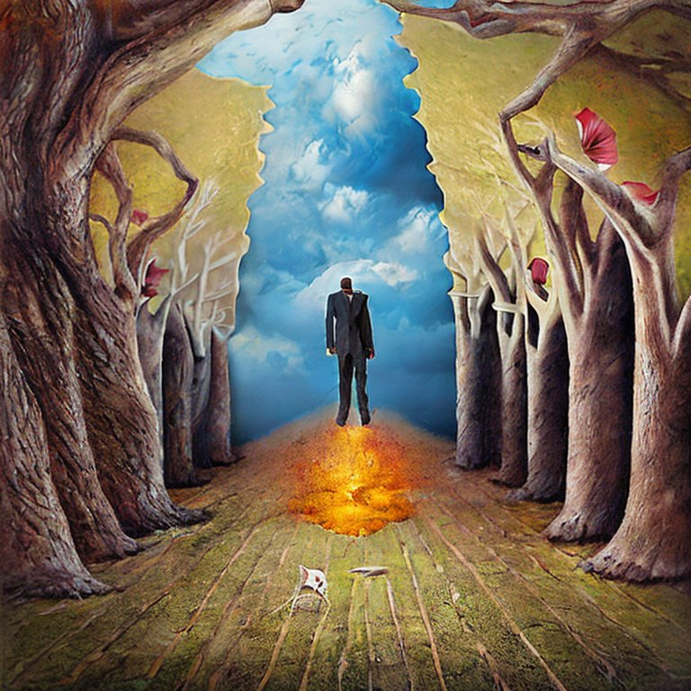

# X------------Assignment # 01 has been successfully completed --------------X